Vidhie Jhunjhunwala

C113

C2

**Title:** Travel management system

**Description**: A travel management system where you can choose from the following options:

1.Customer Management

2.Cabs Management

3. Bookings and Management

4. Charges and Bill

5. Exit

After choosing the desired option, you will be redirected to the page you choose and you just have to read and follow the next steps as displayed on the screen.

**Flowchart:**

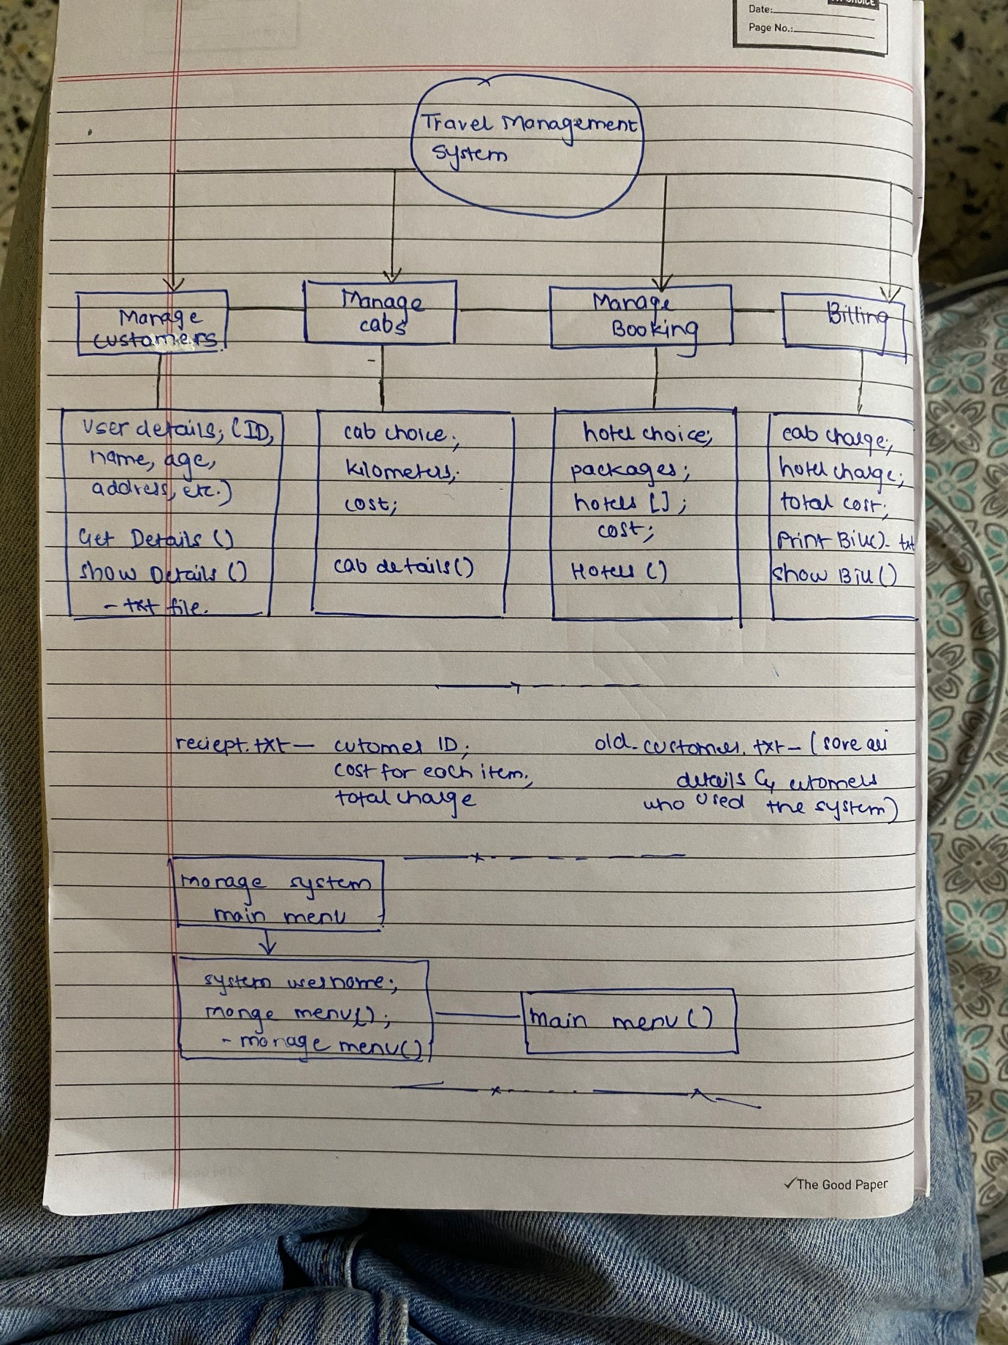

**Algorithm:**

1) Start  
2) Main menu displayed  
3) Enter your choice  
4) Enter 1 (customer management)  
5) Press 1 for new customer or Press 2 to see old customer  
6) Enter 1 (New customer)  
7) Enter credentials  
8) Credentials saved  
9) A note will be displayed saying the details recorded are saved for future purpose  
10) Press 1 to redirect to main menu  
11) Press 1  
12) Redirected to main menu, enter your choice  
13) Enter 2 (cabs management)  
14) Press 1 to choose to rent a standard cab or press 2 to rent a luxury cab  
15) Press 2  
2.  
  
16) To calculate the cost of your ride, enter which type of cab you want and enter the distance in kilometres  
17) Total cost will be displayed  
18) Press 1 to hire this cab or press 2 to select another cab  
19) Press 1  
20) A note saying you have successfully hired luxury cab, go to menu to take receipt  
will be displayed  
21) Press 1 to redirect to main menu  
22) Press 1  
23) Redirected to main menu, enter your choice  
24) Stop

**Code:**

#include<iostream>

#include<fstream>

#include<iomanip>

using namespace std;

void menu();//main menu function prototype

class ManageMenu

{

protected:

string userName; //hide admin name

public:

//virtual void menu(){}

ManageMenu()

{

cout << "\n\n\n\n\n\n\n\n\n\t Enter Your Name to Continue as an Admin: ";

cin >> userName;

menu(); //call to main function to load after executing the constructr

}

~ManageMenu(){} //de

};

class Customer

{

public:

string name, gender, address;

int age, mobileNo, menuBack;

static int cusID;

char all[999];

void getDetails()

{

ofstream out("old-customers.txt", ios::app); //open file using append mode to write customer details

{

cout << "\nEnter Customer ID: ";

cin >> cusID;

cout << "Enter Name: ";

cin >> name;

cout << "Enter Age: ";

cin >> age;

cout << "Enter Mobile Number: ";

cin >> mobileNo;

cout << "Address: ";

cin >> address;

cout << "Gender: ";

cin >> gender;

}

out << "\nCustomer ID: " << cusID << "\nName: " << name << "\nAge: " << age << "\nMobile Number: " << mobileNo << "\nAddress: " << address << "\nGender: " << gender << endl;

out.close();

cout << "\nSaved \nNOTE: We save your details record for future purposes.\n" << endl;

}

void showDetails() //function to show old customer records

{

ifstream in("old-customers.txt");

{

if(!in)

{

cout << "File Error!" << endl;

}

while(!(in.eof()))

{

in.getline(all, 999);

cout << all << endl;

}

in.close();

}

}

};

int Customer::cusID;

class Cabs

{

public:

int cabChoice;

int kilometers;

float cabCost;

static float lastCabCost;

void cabDetails()

{

cout << "We collaborated with fastest, safest, and smartest cab service arround the country" << endl;

cout << "-----------ABC Cabs-----------\n" << endl;

cout << "1. Rent a Standard Cab - Rs.15 for 1KM" << endl;

cout << "2. Rent a Luxury Cab - Rs.25 per 1KM" << endl;

cout << "\nEnter another key to back or," << endl;

cout << "\nTo calculate the cost for your journey.." << endl;

cout << "Enter which kind of cab you need: ";

cin >> cabChoice;

cout << "Enter Kilometers you have to travel: ";

cin >> kilometers;

int hireCab;

if(cabChoice == 1){

cabCost = kilometers * 15;

cout << "\nYour tour will cost " << cabCost << " rupees for a standard cab" << endl;

cout << "Press 1 to hire this cab: or ";

cout << "Press 2 to select another cab: ";

cin >> hireCab;

if (hireCab == 1){

lastCabCost = cabCost;

cout << "\nYou have successfully hired standard cab" << endl;

cout << "Goto Menu to take the receipt" << endl;

}

else if(hireCab == 2){

cabDetails();

}

else{

cout << "Invalid Input! Redirecting to Previous Menu \nPlease Wait!" << endl;

cabDetails();

}

}

else if(cabChoice == 2){

cabCost = kilometers * 25;

cout << "\nYour tour will cost " << cabCost << " rupees for a luxury cab" << endl;

cout << "Press 1 to hire this cab: or ";

cout << "Press 2 to select another cab: ";

cin >> hireCab;

if (hireCab == 1){

lastCabCost = cabCost;

cout << "\nYou have successfully hired luxury cab" << endl;

cout << "Goto Menu to take the receipt" << endl;

}

else if(hireCab == 2){

cabDetails();

}

else{

cout << "Invalid Input! Redirecting to Previous Menu \nPlease Wait!" << endl;

cabDetails();

}

}

else{

cout << "Invalid Input! Redirecting to Previous Menu \nPlease Wait!" << endl;

menu();

}

cout << "\nPress 1 to Redirect Main Menu: ";

cin >> hireCab;

if(hireCab == 1){

menu();

}

else{

menu();

}

}

};

float Cabs::lastCabCost;

class Booking

{

public:

int choiceHotel;

int packChoice1;

int gotoMenu;

static float hotelCost;

void hotels()

{

string hotelNo[] = {"Avendra", "ChoiceYou", "ElephantBay"};

for(int a = 0; a < 3; a++)

{

cout << (a+1) <<". Hotel " << hotelNo[a] << endl;

}

cout << "\nCurrently we collaborated with above hotels!" << endl;

cout << "Press any key to back or\nEnter Number of the hotel you want to book or see details: ";

cin >> choiceHotel;

if(choiceHotel == 1){

cout << "-------WELCOME TO HOTEL AVENDRA-------\n" << endl;

cout << "The Garden, food and beverage. Enjoy all you can drink, Stay cool and get chilled in the summer sun." << endl;

cout << "Packages offered by Avendra:\n" << endl;

cout << "1. Standard Pack" << endl;

cout << "\tAll basic facilities you need just for: Rs.5000.00" << endl;

cout << "2. Premium Pack" << endl;

cout << "\tEnjoy Premium: Rs.10000.00" << endl;

cout << "3. Luxury Pack" << endl;

cout << "\tLive a Luxury at Avendra: Rs.15000.00" << endl;

cout << "\nPress another key to back or\nEnter Package number you want to book: ";

cin >> packChoice1;

if (packChoice1 == 1){

hotelCost = 5000.00;

cout << "\nYou have successfully booked Standard Pack at Avendra" << endl;

cout << "Goto Menu and take the receipt" << endl;

}

else if (packChoice1 == 2){

hotelCost = 10000.00;

cout << "\nYou have successfully booked Premium Pack at Avendra" << endl;

cout << "Goto Menu and take the receipt" << endl;

}

else if (packChoice1 == 3){

hotelCost = 15000.00;

cout << "\nYou have successfully booked Luxury Pack at Avendra" << endl;

cout << "Goto Menu to take the receipt" << endl;

}

else{

cout << "Invalid Input! Redirecting to Previous Menu \nPlease Wait!" << endl;

hotels();

}

cout << "\nPress 1 to Redirect Main Menu: ";

cin >> gotoMenu;

if(gotoMenu == 1){

menu();

}

else{

menu();

}

}

else if(choiceHotel == 2){

cout << "-------WELCOME TO HOTEL CHOICEYOU-------\n" << endl;

cout << "Swimming Pool | Free WiFi | Family Rooms \n Fitness Center | Restaurant & Bar" << endl;

cout << "Packages Offered by ChoiceYou:\n" << endl;

cout << "1. Family Pack" << endl;

cout << "\t Rs.15000.00 for a day" << endl;

cout << "2. Couple Pack" << endl;

cout << "\t Rs.10000.00 for a day" << endl;

cout << "3. Single Pack" << endl;

cout << "\t 5000.00 for a day" << endl;

cout << "\nPress another key to back or\nEnter Package number you want to book: ";

cin >> packChoice1;

if (packChoice1 == 1){

hotelCost = 15000.00;

cout << "You have successfully booked Family Pack at ChoiceYou" << endl;

cout << "Goto Menu and take the receipt" << endl;

}

else if (packChoice1 == 2){

hotelCost = 10000.00;

cout << "You have successfully booked Couple Pack at ChoiceYou" << endl;

cout << "Goto Menu and take the receipt" << endl;

}

else if (packChoice1 == 3){

hotelCost = 5000.00;

cout << "You have successfully booked Single Pack at ChoiceYou" << endl;

cout << "Goto Menu and take the receipt" << endl;

}

else{

cout << "Invalid Input! Redirecting to Previous Menu \nPlease Wait!" << endl;

hotels();

}

cout << "\nPress 1 to Redirect Main Menu: ";

cin >> gotoMenu;

if(gotoMenu == 1){

menu();

}

else{

menu();

}

}

else if(choiceHotel == 3){

cout << "-------WELCOME TO HOTEL ELEPHANTBAY-------\n" << endl;

cout << "Set in tropical gardens on the banks of the Maha Oya river While Seeing Elephants" << endl;

cout << "Amazing offer in this summer: Rs.5000.00 for a one day!!!" << endl;

cout << "\nPress another key to back or\nPress 1 to book this special package: ";

cin >> packChoice1;

if (packChoice1 == 1){

hotelCost = 5000.00;

cout << "You have successfully booked ElephantBay Special Pack" << endl;

cout << "Goto Menu and take the receipt" << endl;

}

else{

cout << "Invalid Input! Redirecting to Previous Menu \nPlease Wait!" << endl;

hotels();

}

cout << "\nPress 1 to Redirect Main Menu: ";

cin >> gotoMenu;

if(gotoMenu == 1){

menu();

}

else{

menu();

}

}

else{

cout << "Invalid Input! Redirecting to Previous Menu \nPlease Wait!" << endl;

menu();

}

}

};

float Booking::hotelCost;

class Chargers : public Booking, Cabs, Customer //Multiple Inheritance of some other classes to Chargers

{

public:

void printBill()

{

ofstream outf("receipt.txt"); //receipt for bought items

{

outf << "--------ABC Travel Agency--------" << endl;

outf << "-------------Receipt-------------" << endl;

outf << "_________________________________" << endl;

outf << "Customer ID: " << Customer::cusID << endl << endl;

outf << "Description\t\t Total" << endl;

outf << "Hotel cost:\t\t " << fixed << setprecision(2) << Booking::hotelCost << endl;

outf << "Travel (cab) cost:\t " << fixed << setprecision(2) << Cabs::lastCabCost << endl;

outf << "_________________________________" << endl;

outf << "Total Charge:\t\t " << fixed << setprecision(2) << Booking::hotelCost+Cabs::lastCabCost << endl;

outf << "_________________________________" << endl;

outf << "------------THANK YOU------------" << endl;

}

outf.close();

//cout << "Your receipt printed, please get it from the file saved path:D" << endl;

}

void showBill()

{

ifstream inf("receipt.txt");

{

if(!inf)

{

cout << "File Error!" << endl;

}

while(!(inf.eof()))

{

inf.getline(all, 999);

cout << all << endl;

}

}

inf.close();

}

};

void menu() //menu function contain main menu

{

int mainChoice;

int inChoice;

int gotoMenu;

cout << "\t\t * ABC Travels *\n" << endl;

cout << "-------------------------Main Menu--------------------------" << endl;

cout << "\t _ _ _ _ _ _ _ _ _ _ _ _ _ _ _ _ _ _ _ _ " << endl;

cout << "\t|\t\t\t\t\t|" << endl;

//cout << "\t|\tAgency System Management -> 0" << endl;

cout << "\t|\tCustomer Management -> 1\t|" << endl;

cout << "\t|\tCabs Management -> 2\t|" << endl;

cout << "\t|\tBookings Management -> 3\t|" << endl;

cout << "\t|\tCharges & Bill -> 4\t|" << endl;

cout << "\t|\tExit -> 5\t|" << endl;

cout << "\t|\t\t\t\t\t|" << endl;

cout << "\t|_ _ _ _ _ _ _ _ _ _ _ _ _ _ _ _ _ _ _ _|" << endl;

cout << "\nEnter Choice: ";

cin >> mainChoice;

Customer a2; //creating objects

Cabs a3;

Booking a4;

Chargers a5;

/*if(mainChoice == 0){

}*/

if(mainChoice == 1){

cout << "------Customers------\n" << endl;

cout << "1. Enter New Customer"<< endl;

cout << "2. See Old Customers"<< endl;

cout << "\nEnter choice: ";

cin >> inChoice;

if(inChoice == 1){

a2.getDetails();

}

else if(inChoice == 2){

a2.showDetails();

}

else{

cout << "Invalid Input! Redirecting to Previous Menu \nPlease Wait!" << endl;

menu();

}

cout << "Press 1 to Redirect Main Menu: ";

cin >> gotoMenu;

if(gotoMenu == 1){

menu();

}

else{

menu();

}

}

else if(mainChoice == 2){

a3.cabDetails();

}

else if(mainChoice == 3){

cout << "--> Book a Luxury Hotel using the System <--\n" << endl;

a4.hotels();

}

else if(mainChoice == 4){

cout << "-->Get your receipt<--\n" << endl;

a5.printBill();

cout << "Your receipt is already printed you can get it from file path\n" << endl;

cout << "to display the your receipt in the screen, Enter 1: or Enter another key to back main menu: ";

cin >> gotoMenu;

if(gotoMenu == 1){

a5.showBill();

cout << "Press 1 to Redirect Main Menu: ";

cin >> gotoMenu;

if(gotoMenu == 1){

menu();

}

else{

menu();

}

}

else{

menu();

}

}

else if(mainChoice == 5){

cout << "\n\n\t--GOOD-BYE!--" << endl;

ManageMenu();

}

else{

cout << "Invalid Input! Redirecting to Previous Menu \nPlease Wait!" << endl;

menu();

}

}

int main()

{

ManageMenu startObj;

return 0;

}

**Output:**

